

**YEAR: 7**

**2021**

**SUBJECT: Science**

**Semester 2**

**Term 4**

**TEST: Mixtures**

**TIME: 55 minutes**

**QUESTIONS: 12 Multiple Choice (12 marks)**

**10 Short Answer (28 marks)**

**TOTAL MARKS: 40 marks**

**DO NOT WRITE ON OR MARK THIS PAPER**

**SECTION ONE—MULTIPLE CHOICE** (12 marks)

This section has **12** questions. Answer **all** questions on the separate Multiple-choice Answer Sheet provided.

1. Which one of the following substances is a mixture?
2. Table salt
3. Seawater
4. Gold
5. Oxygen
6. Sugar dissolves easily in water, therefore sugar is said to be:

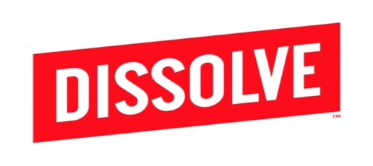

[This Photo](https://www.finsmes.com/2013/09/dissolve-raises-5m-funding.html) by Unknown Author is licensed under [CC BY-NC-ND](https://creativecommons.org/licenses/by-nc-nd/3.0/)

1. insoluble
2. a solution
3. solvent
4. soluble
5. A solid which dissolves in another substance is called a:
6. Sediment
7. Solution
8. Solute
9. Solvent
10. Which of the following is incorrect? An insoluble substance may:

a) Form a solution

b) Float on top of a liquid

c) Form a sediment

d) Form a suspension

1. Decanting is:
2. Pouring liquid from a beaker or flask down the sink
3. Pouring the entire contents of one beaker into another more conveniently sized beaker
4. Tipping a liquid into a filter paper sitting in another beaker
5. Tipping the liquid in one beaker into another, leaving some solid in the bottom of the first beaker

6. Choose the statement that describes the filtration of muddy water.

a) Mud is retained on filter paper and is called filtrate

b) Water passes through filter paper and is called filtrate

c) Water passes while mud is retained on filter paper

d) Water is retained on filter paper and is called filtrate

7. One way to make a milkshake is to add flavouring to milk. To make this type of milkshake more concentrated, you should add more:

a) Whole milk

b) Reduced-fat milk

c) Sugar

d) Flavouring

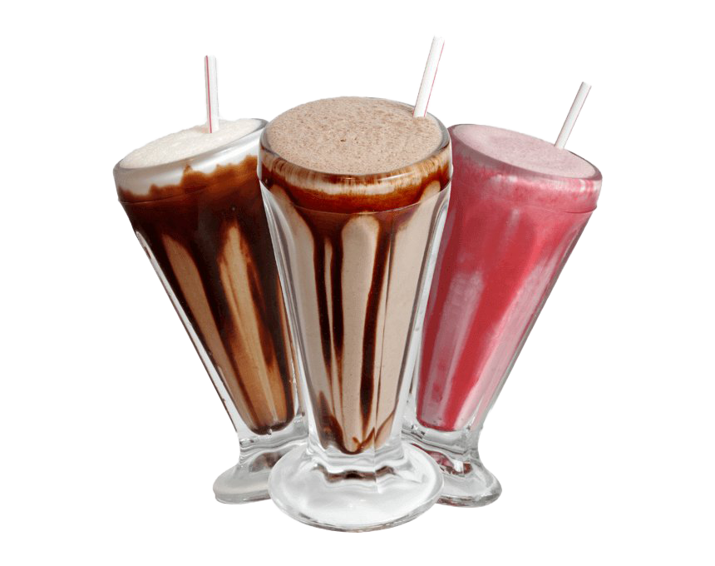8. Which mixture could be separated using magnetic attraction?

a) Nails and paperclips

b) Iron filings and sulfur

c) Iron filings and paperclips

d) Sand and sulfur

9. What is the name of the process used by cooks to separate large grains from small particles?

a) Filtration

b) Sedimentation

c) Sieving

d) Simple separation

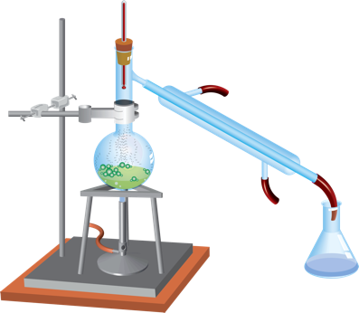10. Which method of separation of different substances in a mixture is shown below?

1. Simple separation
2. Chromatography
3. Filtering
4. Distillation

11. Inks can be separated into their coloured components by:

1. Distillation
2. Crystallisation
3. Filtering
4. Chromatography

12. Which diagram represents a saturated solution?

= dissolved solid particle

= undissolved solid particle

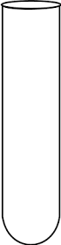

a) b) c) d)

**END OF MULTIPLE-CHOICE SECTION**



**SEMESTER ONE 2021**

**Mixtures Test:**

**ANSWER BOOKLET**

**NAME:**

**FORM:** **DATE:**

|  |  |
| --- | --- |
| **I CAN STATEMENTS** | **QUESTIONS** |
| **MUST**  Describes techniques for separating given materials from a mixture. Identifies pure substances and mixtures from given examples. | 1, 2, 3, 4, 5, 7, 8, 9, 10, 11, 13, 14, 15, 17, 18 |
| **SHOULD**  Selects and describes appropriate separation techniques based on the physical properties of a number of components of a mixture. Explains the difference between pure substances and mixtures. | 6, 12, 15, 16, 20, 22 |
| **COULD**  Selects and explains the most appropriate separation techniques based on the physical properties of components of a mixture. Explains the difference between pure substances and mixtures with reference to chemical bonds | 19, 21 |

**ASSESSMENT KEY**

Multiple Choice Short Answer Total

**/28**

**/12**

**/40**

**SECTION ONE:** Multiple choice answers

Cross (X) through the correct answer.

|  |  |  |  |  |
| --- | --- | --- | --- | --- |
| **1** | a | b | c | d |
| **2** | a | b | c | d |
| **3** | a | b | c | d |
| **4** | a | b | c | d |
| **5** | a | b | c | d |
| **6** | a | b | c | d |
| **7** | a | b | c | d |
| **8** | a | b | c | d |
| **9** | a | b | c | d |
| **10** | a | b | c | d |
| **11** | a | b | c | d |
| **12** | a | b | c | d |

**SECTION TWO: Short Answer (28 marks)**

**Answer the questions in the spaces provided.**

1. Define the following terms:
2. Pure substance (1 mark)

|  |
| --- |
|  |
|  |

1. Colloid (1 mark)

|  |
| --- |
|  |
|  |

1. Simple separation (1 mark)

|  |
| --- |
|  |
|  |

1. Read the following statements and answer the following questions:

Wax is a solid that does NOT dissolve in water.  
Wax does dissolve in kerosene.  
Sugar does dissolve in water.  
Sugar does NOT dissolve in kerosene.  
Kerosene does NOT dissolve in water (3 marks)

1. **Identify** the solvent you would use to make a solution containing wax.

**____________________________________________________________________**

1. **Identify** two substances that are insoluble in water.

**____________________________________________________________________**

1. I**dentify** a substance that is soluble in water.

**____________________________________________________________________**

1. Graffiti remover is used to wash paint from a wall. Is the paint the solvent, solute or solution? **Explain your answer**. (3 marks)

|  |
| --- |
|  |
|  |
|  |
|  |

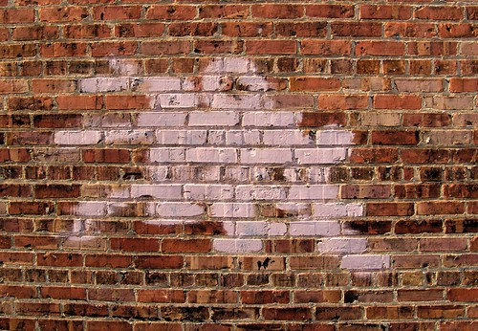

1. Your little sister is watching you put a teaspoon of sugar into a glass of hot water. She makes a comment that ‘the sugar has disappeared”. How do you explain the “disappearance” of the sugar to her? (2 marks)

|  |
| --- |
|  |
|  |
|  |
|  |

1. List two examples of filtering or sieving used around the home. (2 marks)

Example 1: __________________________________________

Example 2: __________________________________________

1. Evaporation is a technique used to separate substances.
2. Give an example of a mixture where evaporation is used to separate substances. (1 mark)

|  |
| --- |
|  |

1. Draw a labelled diagram using correct science skills of the equipment you would use in evaporation. (4 marks)

|  |
| --- |
|  |

1. Using an **example**, **explain** how the process by which chromatography can separate substances. (3 marks)

|  |
| --- |
|  |
|  |
|  |
|  |
|  |
|  |
|  |

1. In gold panning, a mixture of gravel and gold particles are swirled around in water and the gold remains in the pan while the gravel is swirled out into the river with some of the water. **Explain** this separation method. (2 marks)

|  |
| --- |
|  |
|  |
|  |
|  |
|  |
|  |
|  |

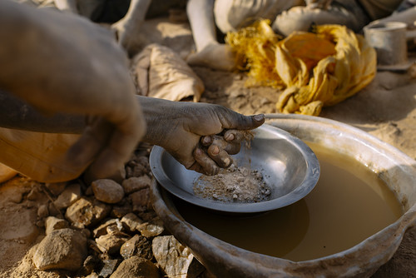

1. Using an example, explain the separation process of magnetic separation.

 (3 marks)

|  |
| --- |
|  |
|  |
|  |
|  |
|  |
|  |
|  |

1. Explain how a boiling point of a liquid can be used to separate a mixture.

(2 marks)

|  |
| --- |
|  |
|  |
|  |
|  |
|  |
|  |
|  |

**END OF TEST**

**Please check your work!**